**Title-** Agriculture Precision: Rainfall Prediction and Crop Recommendation

**Abstract:**

**Project Overview:**• Presents an integrated machine learning-based system for agricultural decision-making.  
• Uses Decision Tree Regressor and Decision Tree Classifier models to predict rainfall and recommend crops.  
• Utilizes a Flask-based web application for user-friendly data input and prediction.  
• Promotes sustainable farming practices by reducing uncertainty in planning.  
• Uses Python, scikit-learn, and Flask for lightweight, scalable solution.  
• Future extensions may integrate real-time data feeds from IoT sensors or weather APIs.  
• Demonstrates how machine learning can bridge technology and agriculture.  
• Potential to become an essential tool for precision agriculture with further refinements.

**Step To Run the code:**  
  
**Step 1:** Set Up Your Environment  
• Install Python from the official website.  
• Ensure VS Code is installed from the Visual Studio Code website.  
• Install the Python extension for VS Code from the Extensions Marketplace.  
  
**Step 2:** Create a Project Directory  
• Create a folder for your project and open it in VS Code.  
  
**Step 3:** Set Up a Virtual Environment  
• Open the terminal in VS Code and run `bash` python -m venv venv.  
• Activate the virtual environment on Windows  
  
**Step 4:** Install Required Libraries  
• Run `bash` pip install flask pandas scikit-learn.  
  
**Step 5:** Organize Your Files  
• Create `datasets/`, `models/`, `templates/`.  
• Place dataset files in `datasets/` and add Flask app code in `app.py` and HTML templates in `templates/`.  
  
**Step 6:** Train the Models  
• Run separate Python scripts for crop and rainfall model training.  
  
**Step 7:** Run the Flask App  
• Start the Flask application by running `bash` python app.py.  
  
**Step 8:** Interact with the Application  
• Fill in the form in the web interface to make predictions.  
• Review the predicted results displayed on the result page. 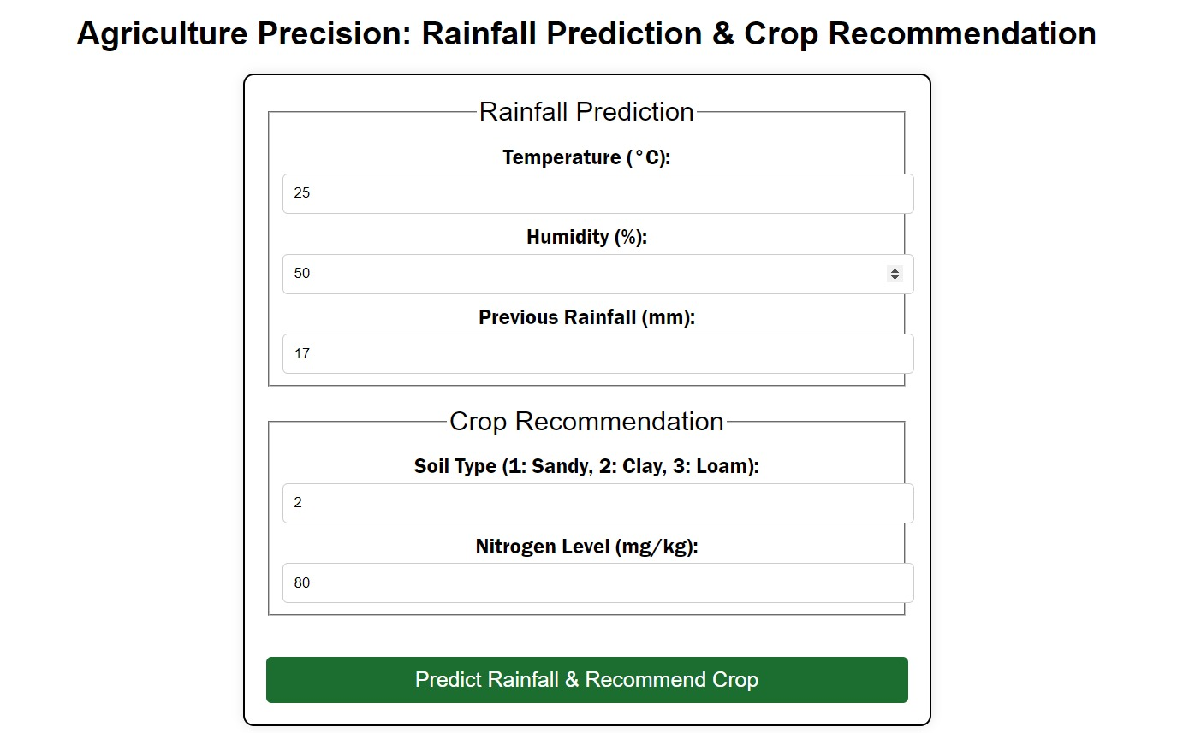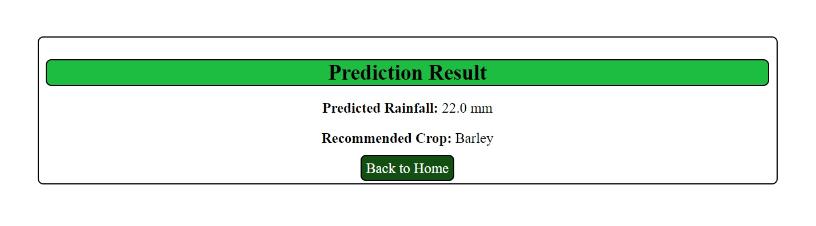

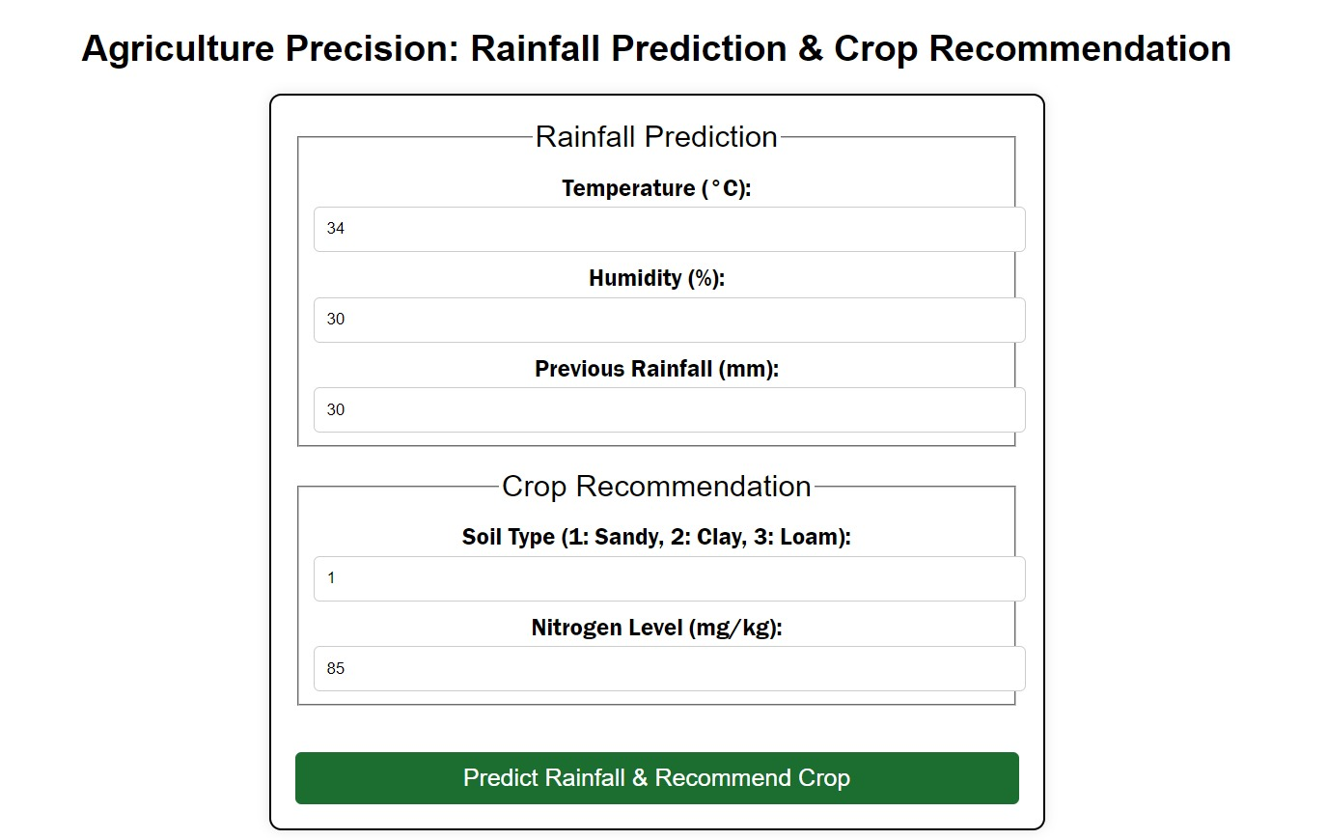

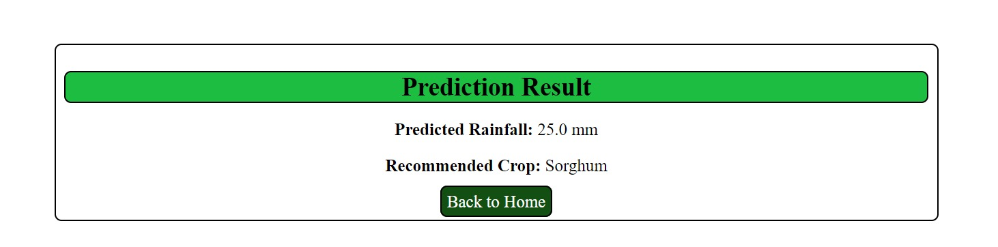

**Result:**

**Project Result Summary:**  
  
• Successful development of an integrated machine learning-based system for predicting rainfall and providing crop recommendations.  
• Accurate Rainfall Prediction Model: A Decision Tree Regressor model was trained to predict rainfall based on environmental factors.  
• Crop Recommendation System: A Decision Tree Classifier model was developed to recommend crops based on soil type, nitrogen levels, predicted rainfall, and temperature.  
• Web-based Application for Ease of Use: The system was deployed using Flask, providing an easy-to-use web interface for farmers with limited technical knowledge.  
• Integrated Approach to Agricultural Planning: The system integrates rainfall forecasting with crop recommendation, minimizing crop failure by aligning crop selection with expected climatic conditions.  
• Model Deployment and Storage: The trained models were saved using Pickle for efficient storage and easy loading during real-time usage.  
• Potential for Future Enhancements: The system is designed with scalability, allowing for future integration of real-time data sources.